|  | **Product Design**  LEGO Mindstorms Locator  **LML**  Anusha Majeed  Jonathan Collazo  Mahmoud Algharbawi  Sahardeed Ahmed  Vandit Jindal |
| --- | --- |
|  |  |

| ***Revision Number*** | ***Revision Date*** | ***Summary of Changes*** | ***Author(s)*** |
| --- | --- | --- | --- |
| *1.0* | *10/06/2022* | *Creation of Document* | *LML* |
| *2.0* | *10/22/2022* | *TA Feedback from Canvas* | *LML* |
| *3.0* | *11/10/2022* | *Updated Home Key Screen and Menu key Screen* | *LML* |
| *4.0* | *12/7/2022* | *Add Discussions section to Design Rationale* | *LML* |
| *5.0* | *02/15/2023* | *Update Team Name and Discussion section* | *LML* |
| *6.0* | *03/08/2023* | *Added LEGO Detection Feedback Screen* | *LML* |
| *7.0* | *05/01/2023* | *Updated Home and Menu Screen* | *LML* |

| *8.0* | *10/20/2023* | *A-Team Additional Diagrams* | *SOA* |
| --- | --- | --- | --- |

# Class Diagram(s)

[**Class Diagram**](https://drive.google.com/file/d/1rD9cdoXmKk-O7O7VC0kqdfNz40CrPLTC/view?usp=sharing)**- The purpose of the class diagram is to show relationships between view screens, the users, and the database. The purpose of our app is to help users locate LEGO pieces within a tray. On the home screen, users will be able to view various LEGO pieces. The home screen uses the database to show users various LEGO pieces. When users want to locate a LEGO piece, the user will select the LEGO piece they are looking for. The Camera screen uses the database to show users various LEGO pieces for selection and help identify LEGO pieces. Lastly, the menu screen allows users to modify the settings of our app.**A diagram of a computer

**Flow charts:**

[**Home/Parts Page**](https://drive.google.com/file/d/1KgXW89yb8PAc4jN6GTMSY1DCJGLKe5pi/view?usp=sharing) **- The purpose of the home Flowchart is to show the user story of the home screen. When users are on the home screen, users will be able to look through a list of various LEGO pieces.**

[**Camera Page**](https://drive.google.com/file/d/1MejldpLET5C5flZ0Wp4TJT8ymOEmaALk/view?usp=sharing)**- The purpose of the camera Flowchart is to show the user story of the camera screen. The user will select the LEGO piece they are looking for and will take a picture of the LEGO trays. The app will tell the user the location of the LEGO piece the user is looking for.**

[**Options Page**](https://drive.google.com/file/d/1HQyR2fu-EFVHlOMwwzmOKwoNvFUHf13F/view?usp=sharing)**- The purpose of the option Flowchart is to show the user story of the options screen. When users are on the options screen, users will be able to modify settings in the app.**

# ER Diagram(s)

* [**ER Diagram for Legos**](https://drive.google.com/file/d/1CuKnEK4GtnPb6QaSa31IkElL_5ne2ZGj/view?usp=sharing) **- The purpose of our ER diagram is to determine what should be included in our database. Our database should have information such as color, size, and shape which can be used to help identify each LEGO piece.**

# 

# 

# Sequence Diagram:

# 

# [Sequence Diagram for LEGO Identification](https://docs.google.com/presentation/d/1dRSbLj8rZkvBHwdmofgNBIe1RyRT9oxgPTC78yTZsz0/edit) - The purpose of our sequence diagram is to illustrate the flow of interactions between different objects and components in a specific use case scenario of our LEGO identification app. This diagram outlines the sequence of messages exchanged between the user, the app, the server, and the database during the LEGO identification process. It visually represents the steps involved in identifying a LEGO piece, from user interaction to database queries and feedback delivery.

# 

# Information Architecture Diagram:

# 

# [Information Architecture Diagram for LEGO Identification](https://docs.google.com/presentation/d/10QpxVauj4EKQNS7F1WwAXTLziStw1P5-o3oWt68j20k/edit) - The purpose of our information architecture diagram is to outline the organization and structure of data within our LEGO identification system. This diagram provides a visual representation of the data flow and relationships between different components in our app. It shows the hierarchical structure of our system, from the user interface to the database, and highlights how data is stored and managed at each level. The diagram helps us understand how user interface components, app logic, server, and database are interconnected to provide seamless LEGO identification services to our users.

# User Interface Wireframe(s)/Screenshot(s)

**App Icon**

* **ScreenID: AppIcon**

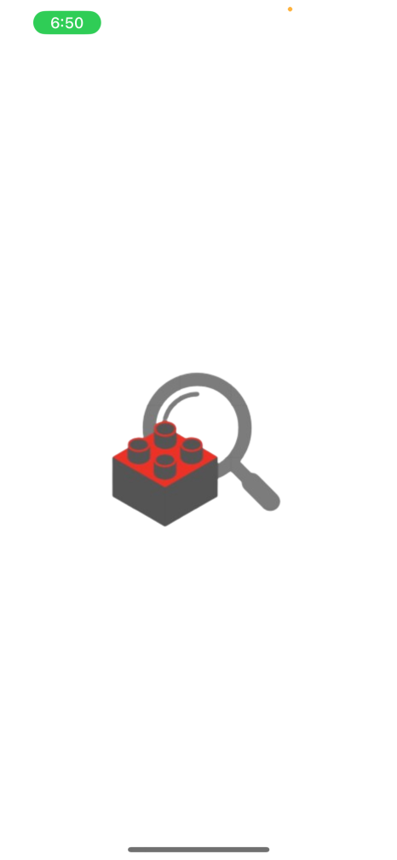

**Captions/Annotations: This icon will be used for iOS and Android.**

**Home Key Screen**

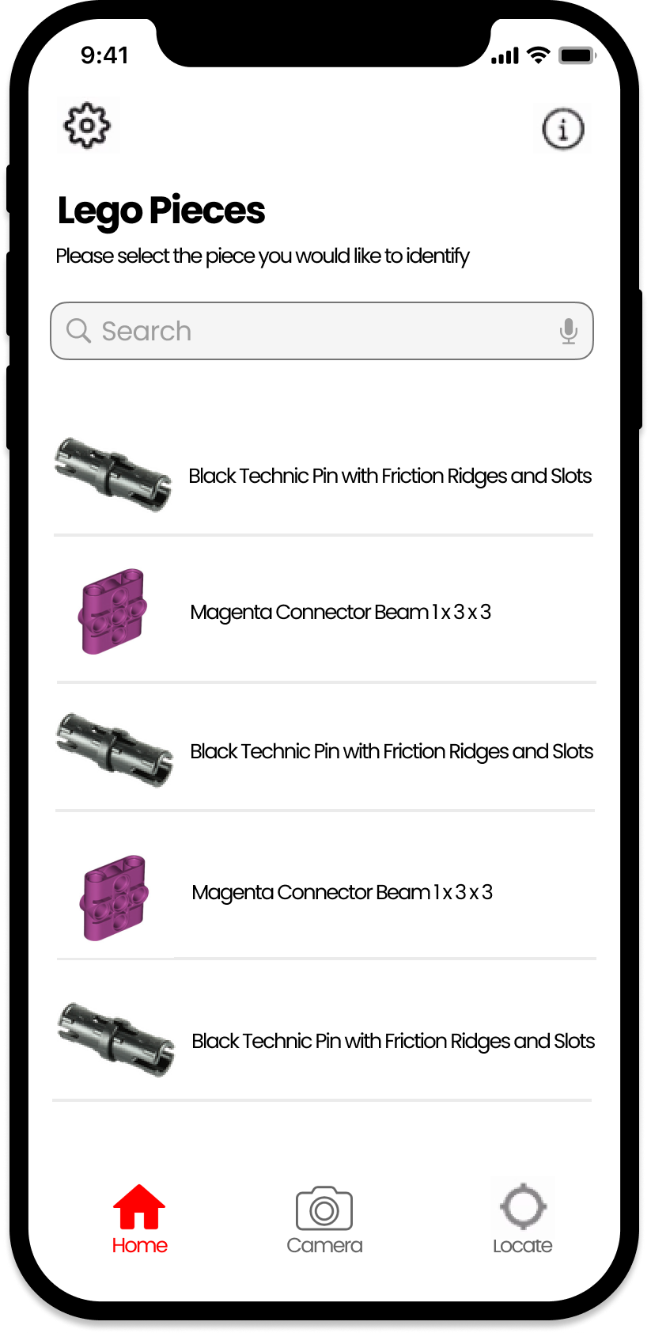

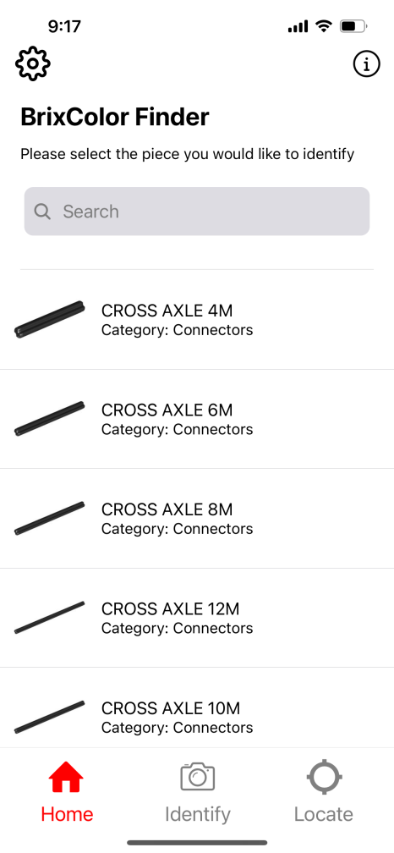

* **ScreenID: HomeKeyScreen**
* **Captions/Annotations: On the home screen, users will be able to view and search various LEGO pieces. The app will show information about the LEGO piece such as name, color, and quantity. The user will be able to search for the LEGO piece they are looking for. The user will also be able to view instructions on how to use the app by selecting the info button.**

**LEGO Card Key Screen**

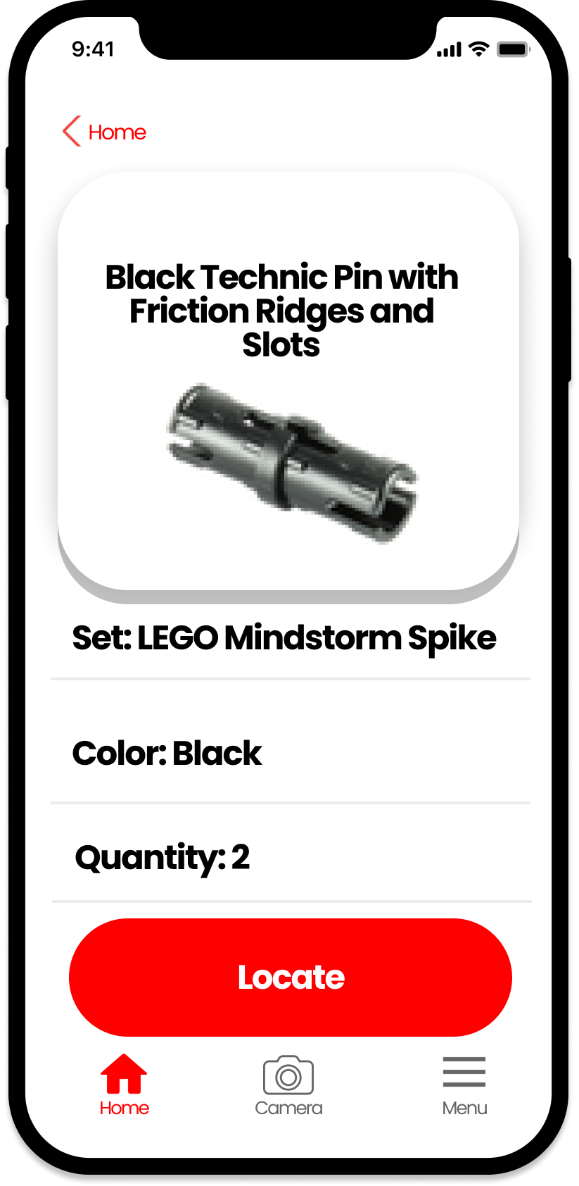

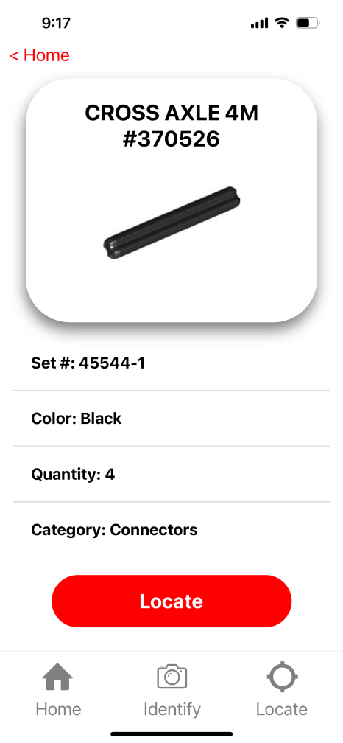

* **ScreenID: LEGOCardKeyScreen**
* **Captions/Annotations: On the LEGO Card screen, users will be able to see information about the LEGO piece such as name, set, color, and quantity. The user will be able to search for the LEGO piece they are looking for by selecting the locate button.**

**Instructions Key Screen**

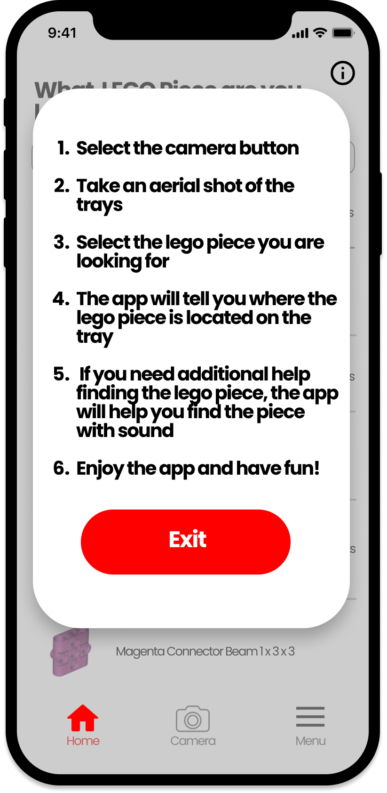

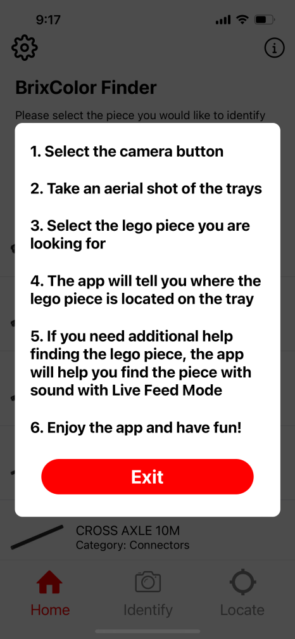

* **ScreenID: InstructionsKeyScreen**
* **Captions/Annotations: On the instructions screen, users will be able to view the instructions on how to use the app by selecting the info button.**

**Camera Permissions Key Screen**

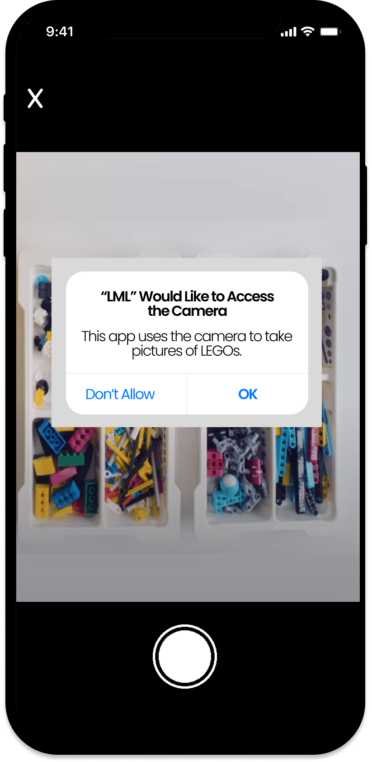

* **ScreenID: CameraPermissionsKeyScreen**
* **Captions/Annotations: After the user has selected what LEGO piece they are looking for, the app will ask the user if the app has permission to use the camera to take pictures of LEGOs.**

**Camera for Live Feed Mode Key Screen**

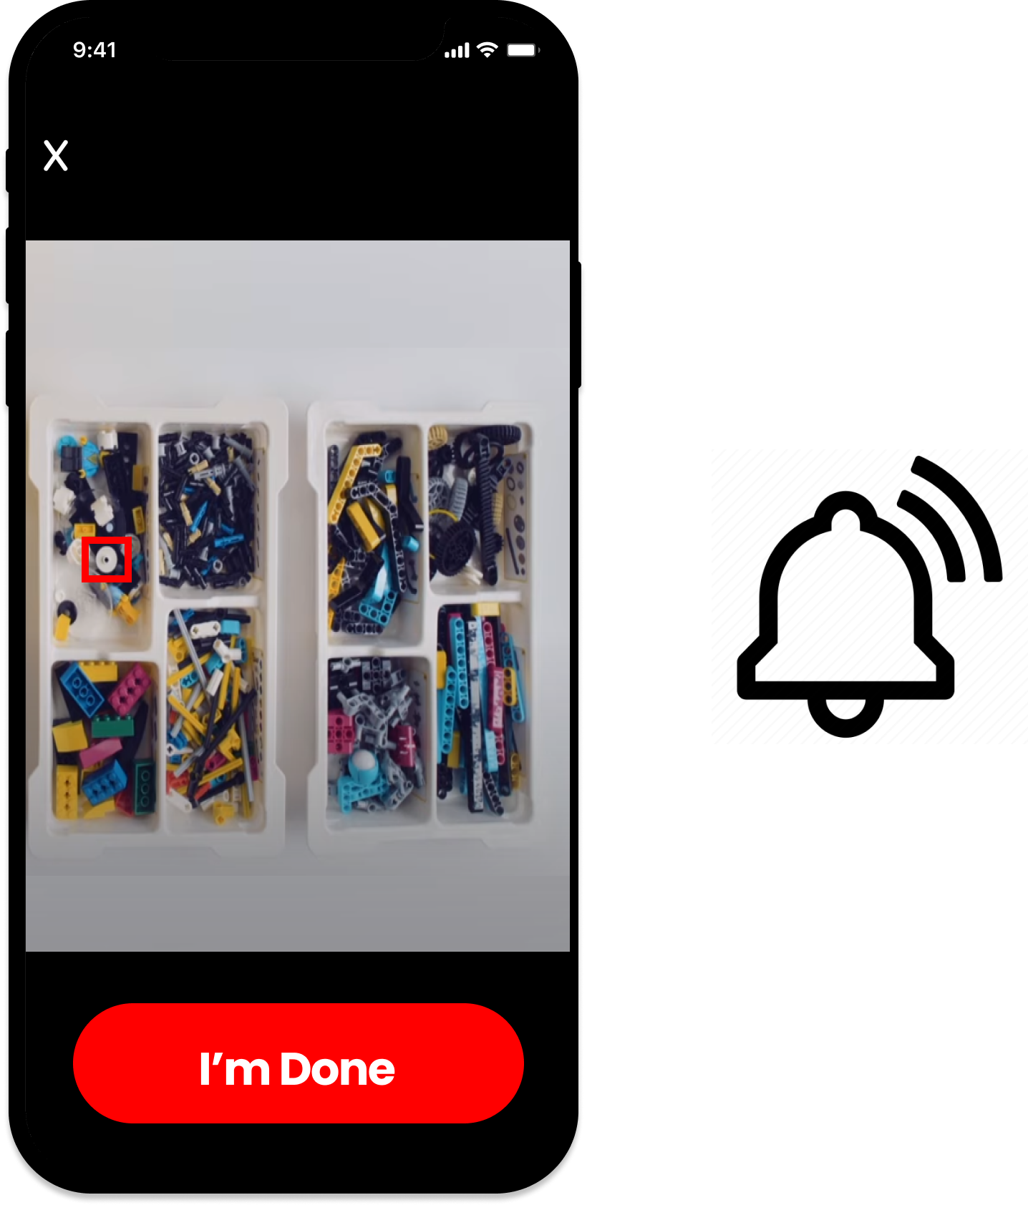

* **ScreenID: CameraForLiveFeedModeKeyScreen**
* **Captions/Annotations: After the user has allowed the app permission to the camera, the users will be able to use the camera to actively scan the trays in Live Feed Mode. In Live Feed Mode, the desired LEGO piece will be highlighted when the app finds the location of the LEGO piece. Sounds will be activated when the phone reaches closer to the LEGO piece.**

**Camera for Picture Mode Key Screen**

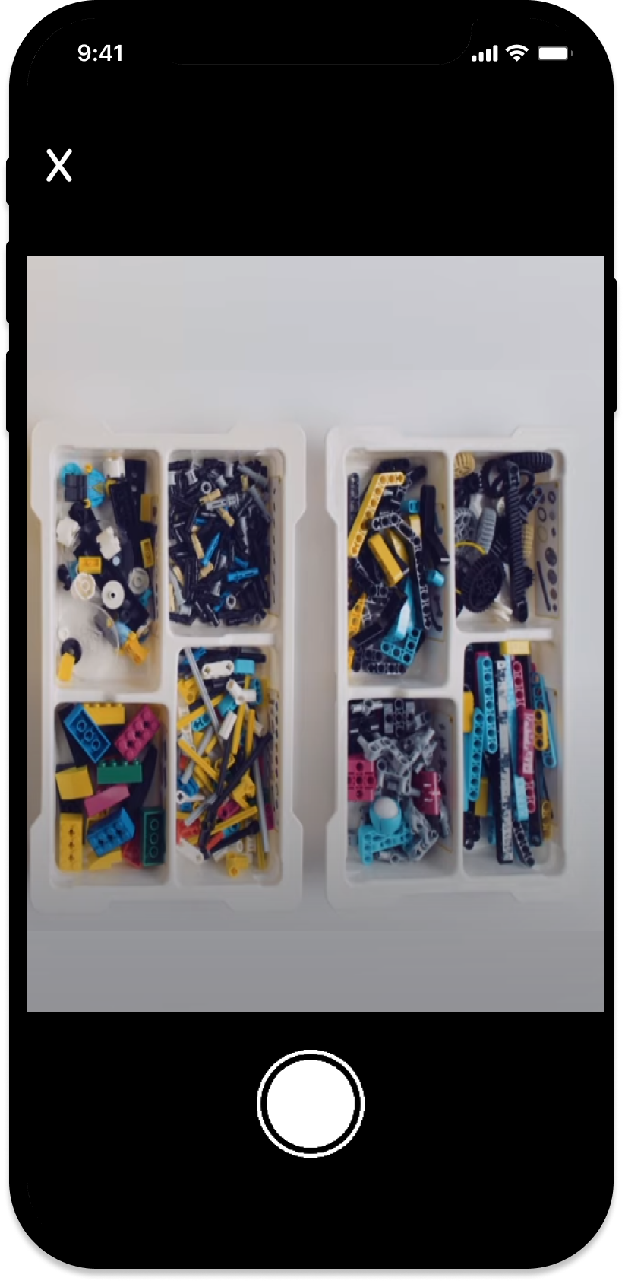

* **ScreenID: CameraForPictureModeKeyScreen**
* **Captions/Annotations: After the user has allowed the app permission to the camera, the users will be able to take pictures of the trays in Picture Mode.**

**LEGO Location for Picture Mode Key Screen**

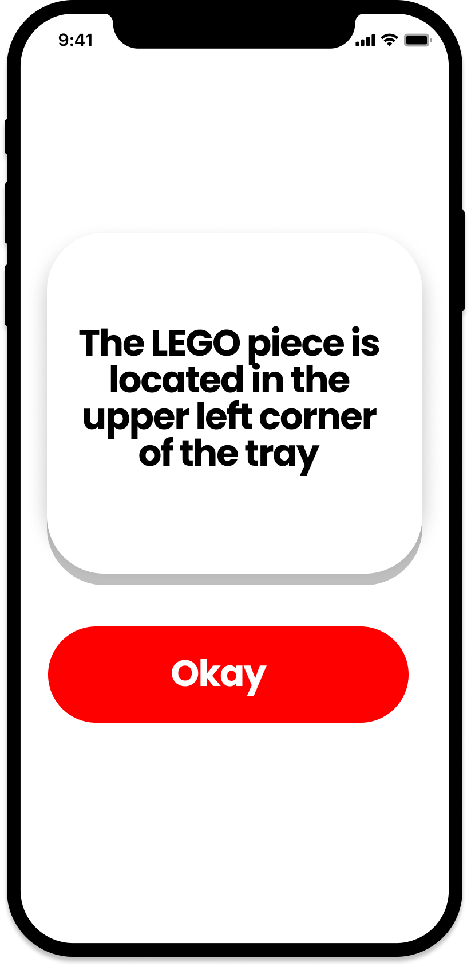

* **ScreenID: LEGOLocationForPictureModeKeyScreen**
* **Captions/Annotations: After the user takes a picture, the app will analyze the picture and will tell the user the location of the LEGO piece.**

**LEGO Detection Feedback for Picture Mode Key Screen**

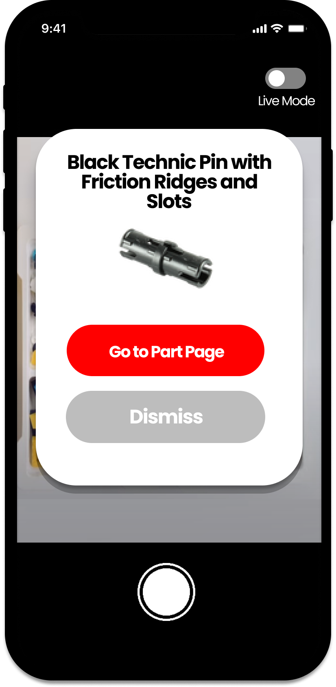

* **ScreenID: LEGODectectionFeedbackForPictureModeKeyScreen**
* **Captions/Annotations: After the user takes a picture, the app will analyze the picture and will tell the user the name of the LEGO piece.**

**LEGO Detection Feedback for Live Mode Key Screen**

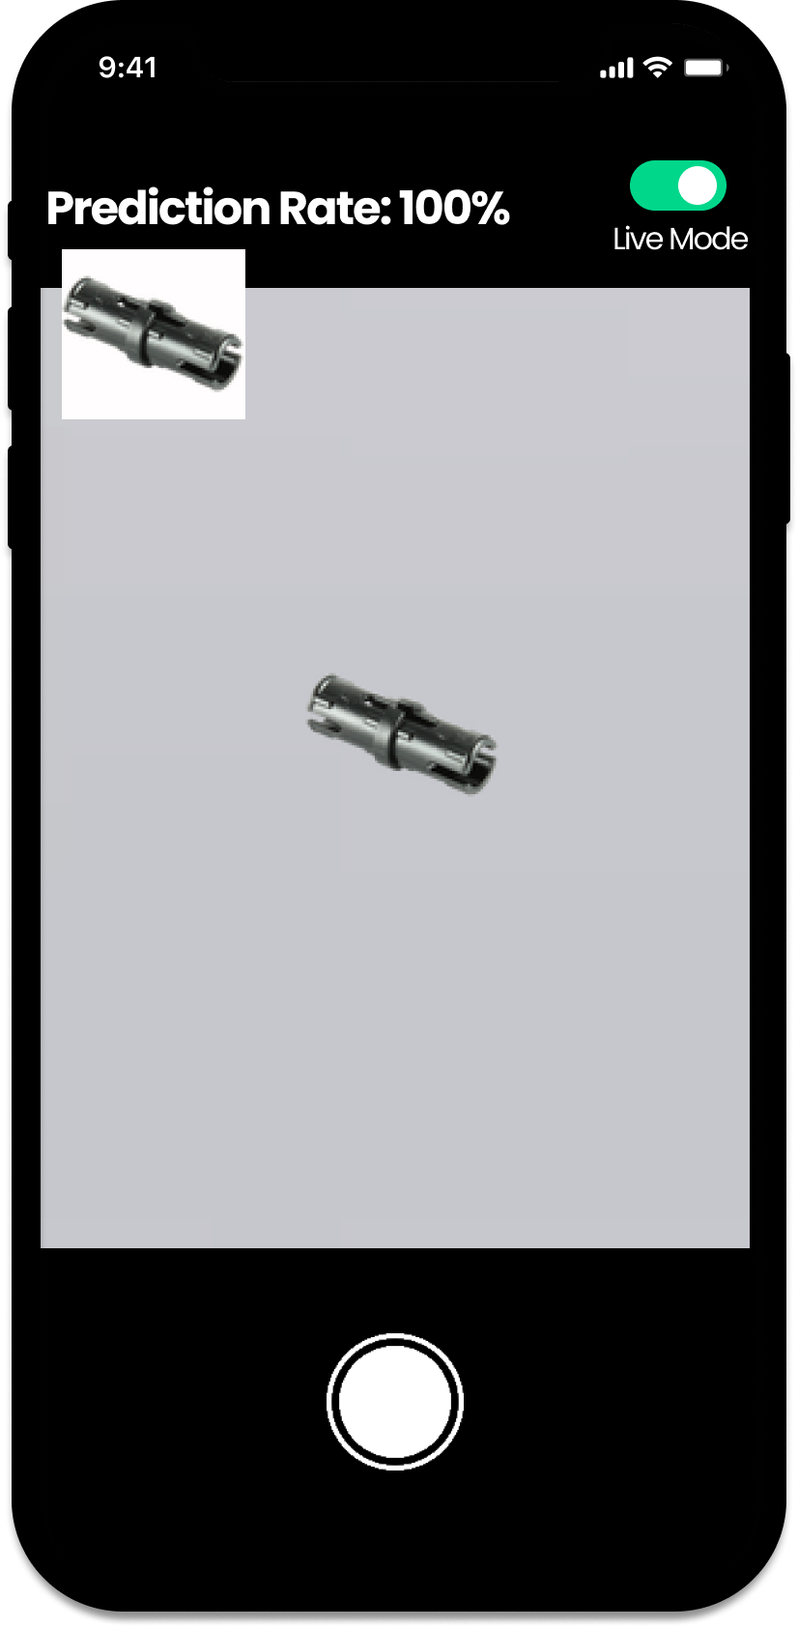

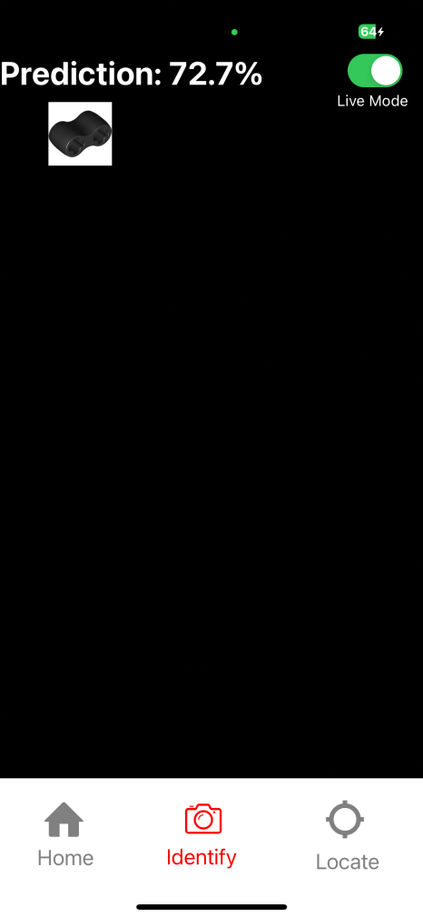

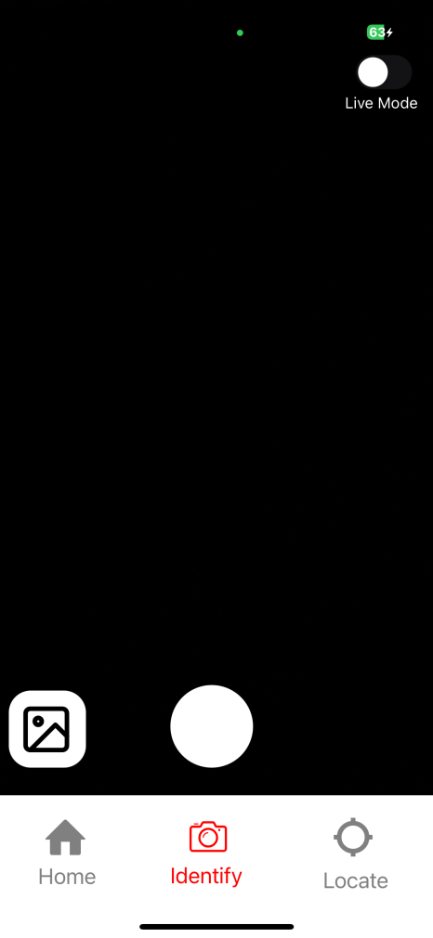

* **ScreenID: LEGODectectionFeedbackForLiveModeKeyScreen**
* **Captions/Annotations: When the user actively scans a LEGO piece, the app will analyze the picture and identify the LEGO piece.**

**Menu Key Screen**

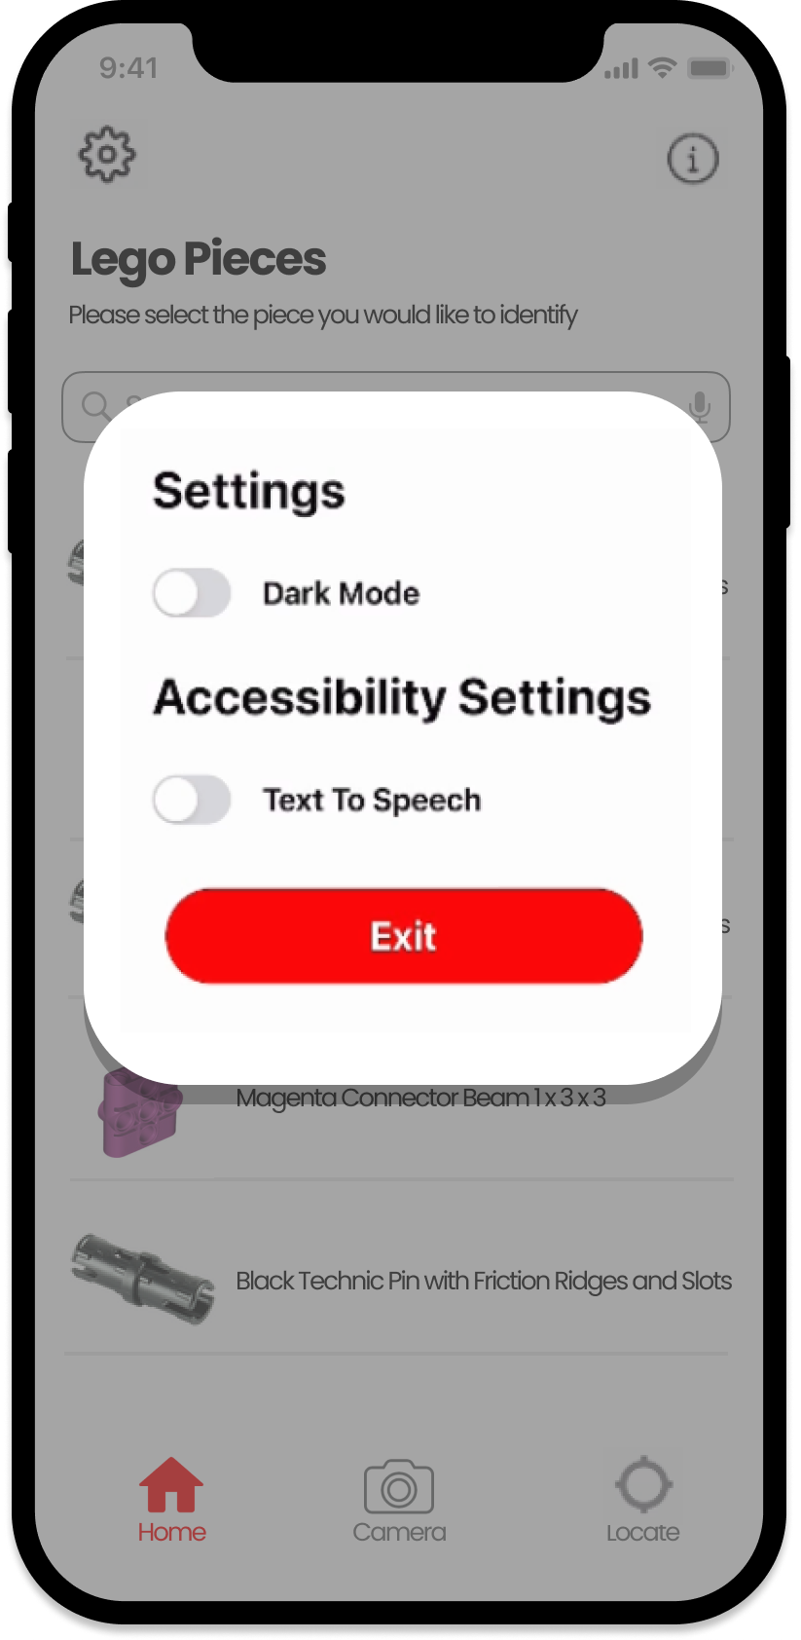

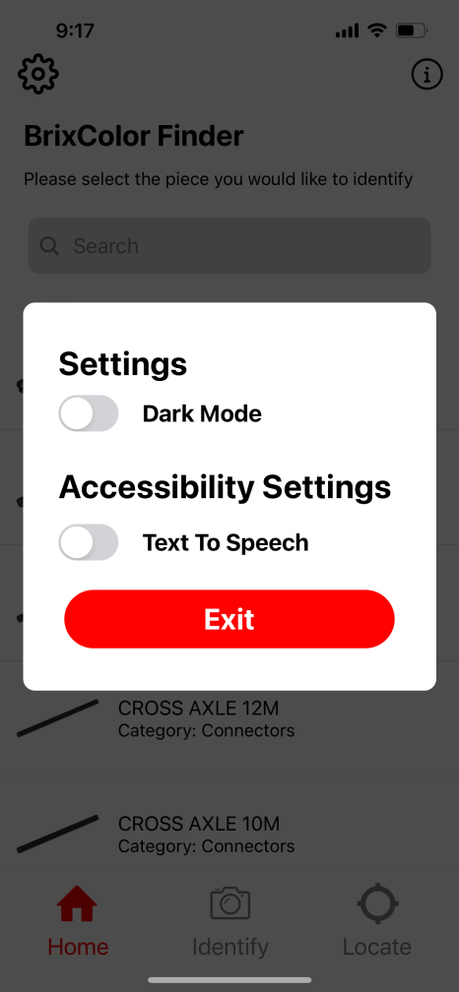

* **ScreenID: MenuKeyScreen**
* **Captions/Annotations: On the menu screen, users will be to modify settings. The user will be able to enable dark mode and accessibility features.**

**Piece Detail Screen:**

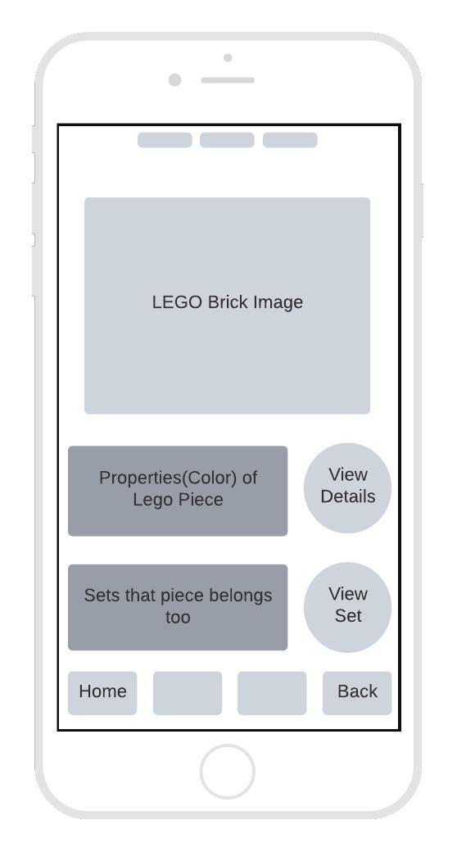

# Design Summary

* **The user should be able to access the app.**
* **The user is navigated to the home screen with all the parts**
  + **Navigation bar is on the bottom of the page**
    - **contains camera part search in the middle, the home page to the left, and setting options to the right**
  + **User can search for a part using the search bar**
* **User can navigate to camera page to identify parts**
  + **camera permissions are required**
  + **user can turn on part identification by voice on camera page**
  + **Navigation bar persists at the bottom**
* **User can navigate to the settings page to enable dark mode, view help screen, or learn more about the app**

# Design Rationale

**INITIAL REJECTED DESIGN IDEAS:**

* **5 navigation buttons**
  + **Too cluttered**
* **navigate by sound**
  + **this should be an option as opposed to a specific feature**
* **App logo color**
  + **chose a logo that looks most similar to LEGO, can change if needed**
* **Square Buttons**
  + **We decided to use semi-round buttons**
* **Widgets for specific lego sets**
  + **we decided to keep everything in the same list**

**INITIAL ISSUES:**

* **choosing what types of files in database**
  + **Ex: 3d pictures, still images**
* **choosing logo type**
* **choosing app design/pages**

**DISCUSSIONS**

* **Possibly change layout for home screen**
* **Determine colors for dark mode**
* **Implementation of LEGO Card Key screen**

**CHANGES:**

* **What lego piece are you looking for screen**
  + **We divided to delete this extra screen and decided ask users what lego piece a user is looking for on the home screen**
* **Instructions**
  + **We decided to create an info button that would display the instructions for our app**
* **Image Upload**
  + **We added a function to upload images directly from one’s camera roll**